https://explore.skillbuilder.aws/learn/course/134/play/31418/aws-cloud-practitioner-essentials-all-modules

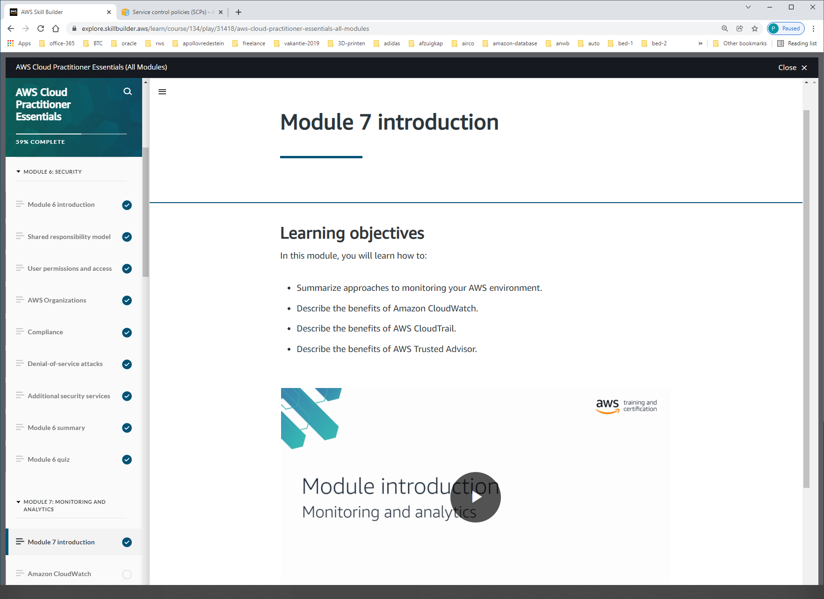

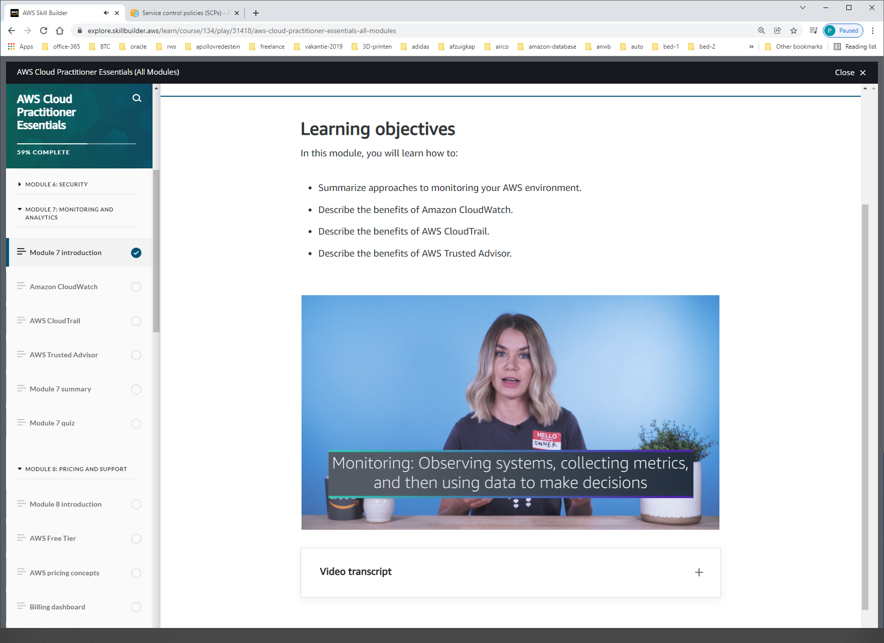

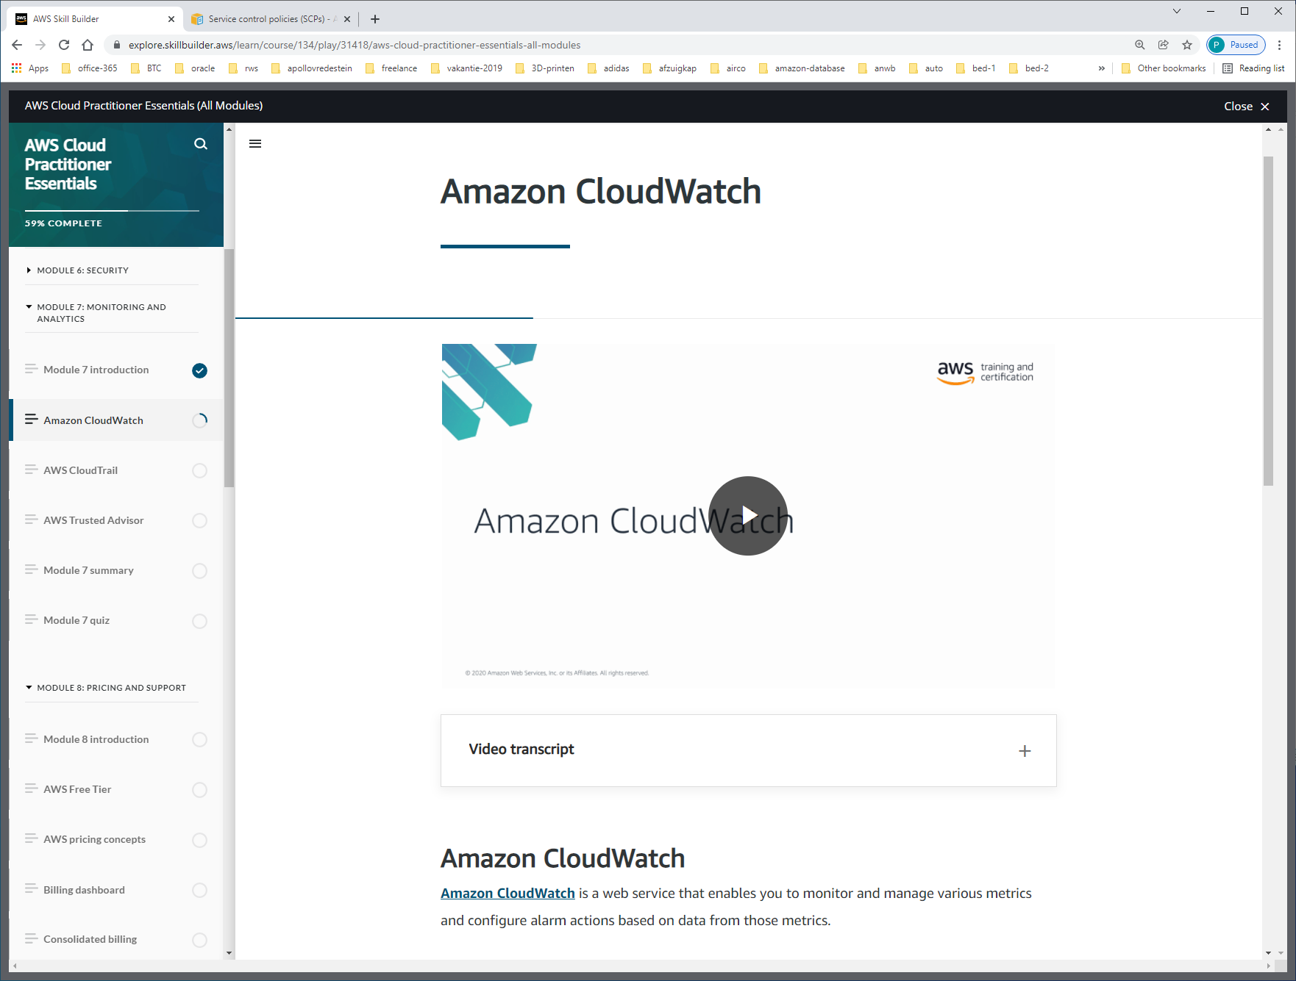

[**Amazon CloudWatch**](https://aws.amazon.com/cloudwatch/) is a web service that enables you to monitor and manage various metrics and configure alarm actions based on data from those metrics.

CloudWatch uses [**metrics**](https://docs.aws.amazon.com/AmazonCloudWatch/latest/monitoring/working_with_metrics.html) to represent the data points for your resources. AWS services send metrics to CloudWatch. CloudWatch then uses these metrics to create graphs automatically that show how performance has changed over time.

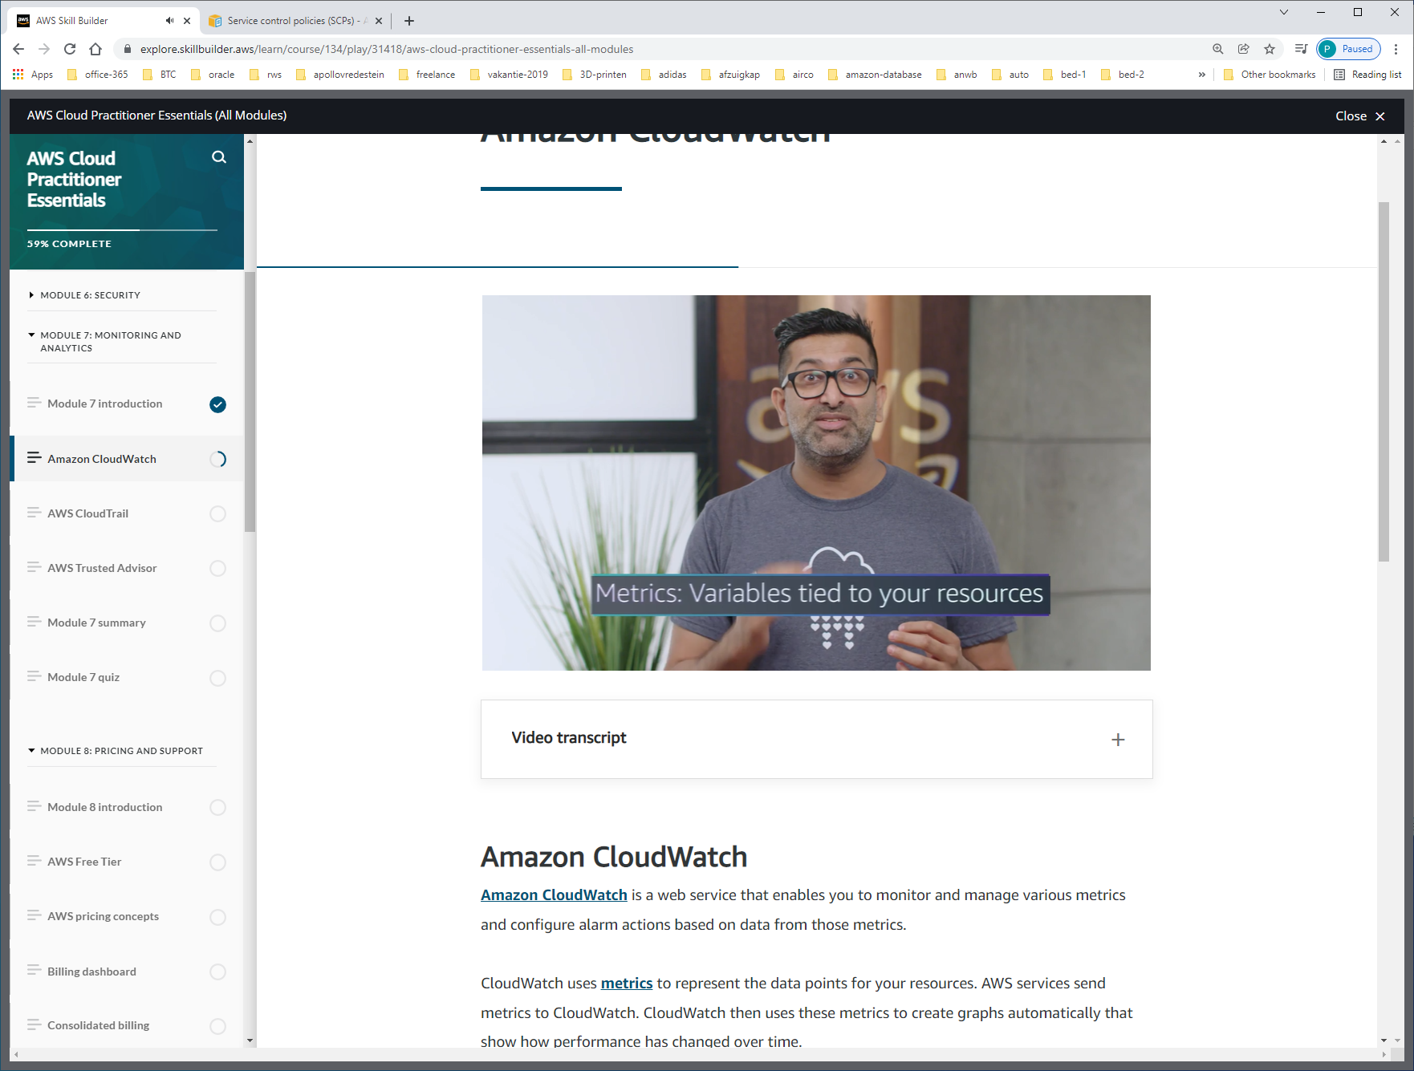

Bijv. Cpu

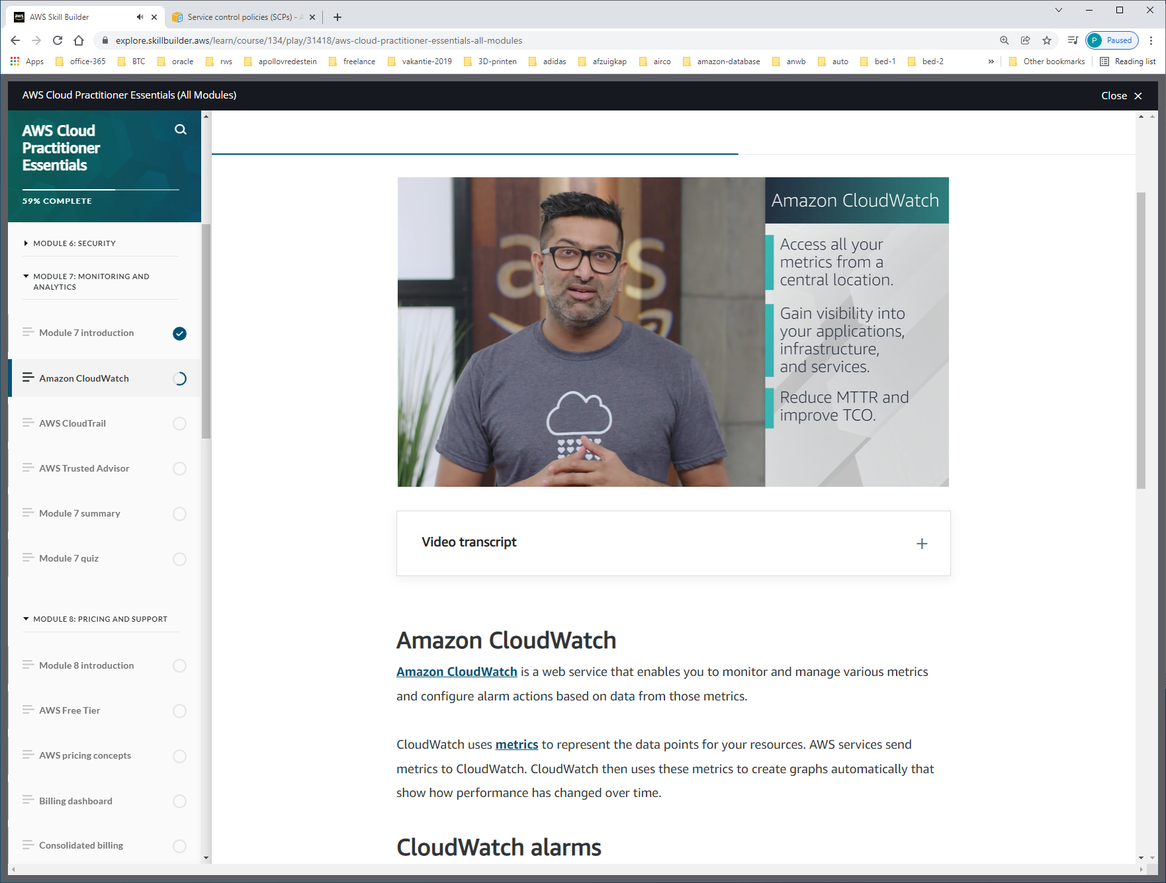

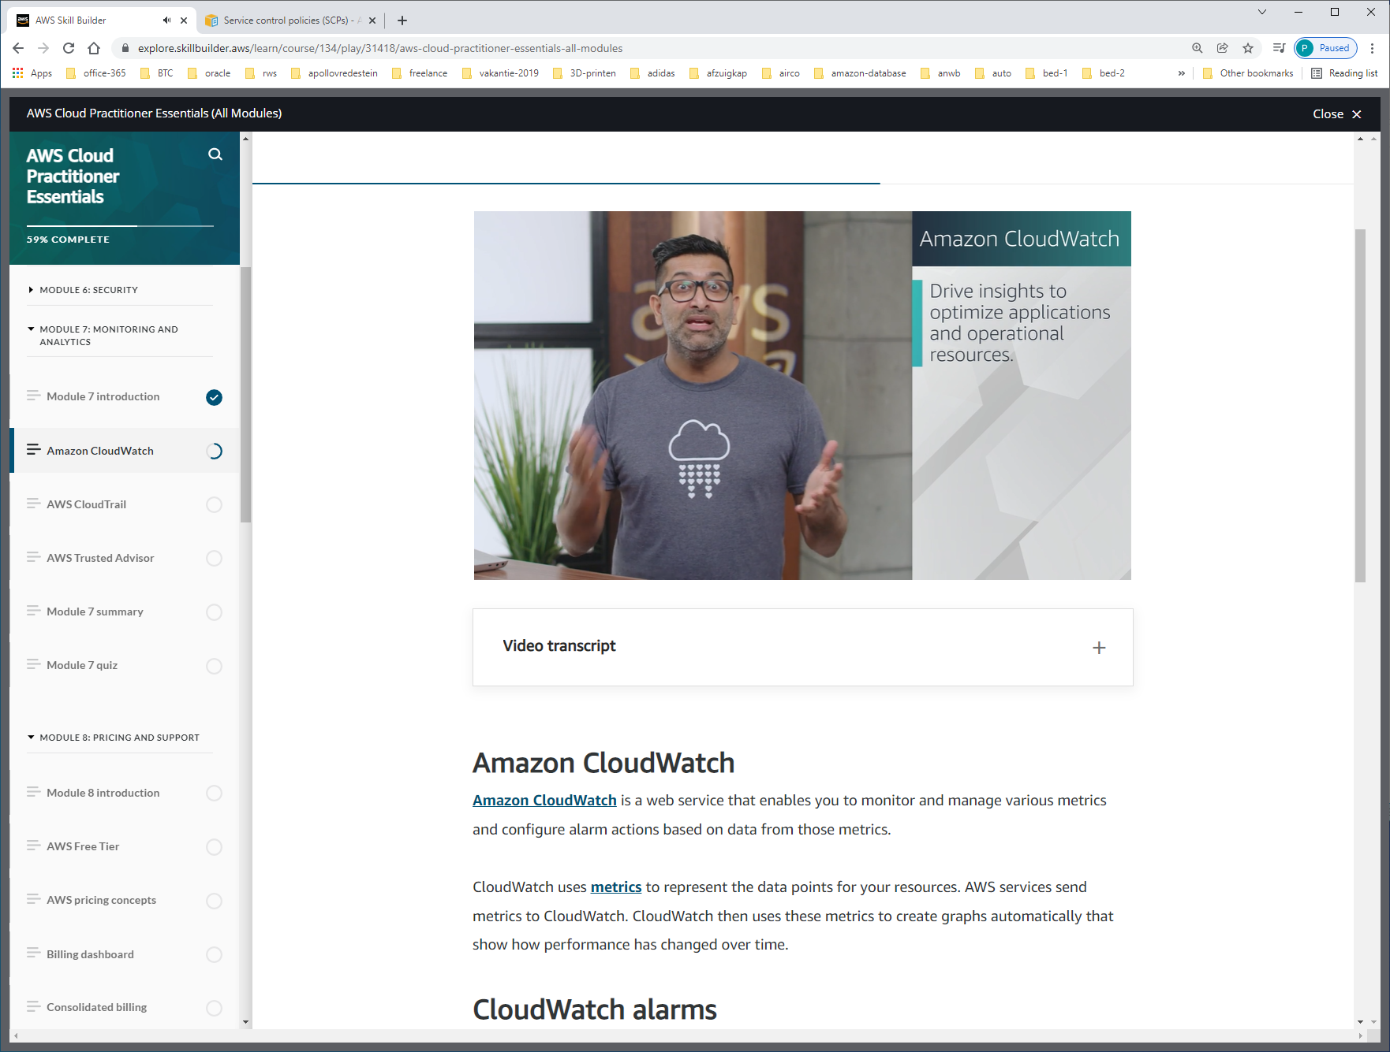

With CloudWatch, you can create [**alarms**](https://docs.aws.amazon.com/AmazonCloudWatch/latest/monitoring/AlarmThatSendsEmail.html) that automatically perform actions if the value of your metric has gone above or below a predefined threshold.

For example, suppose that your company’s developers use Amazon EC2 instances for application development or testing purposes. If the developers occasionally forget to stop the instances, the instances will continue to run and incur charges.

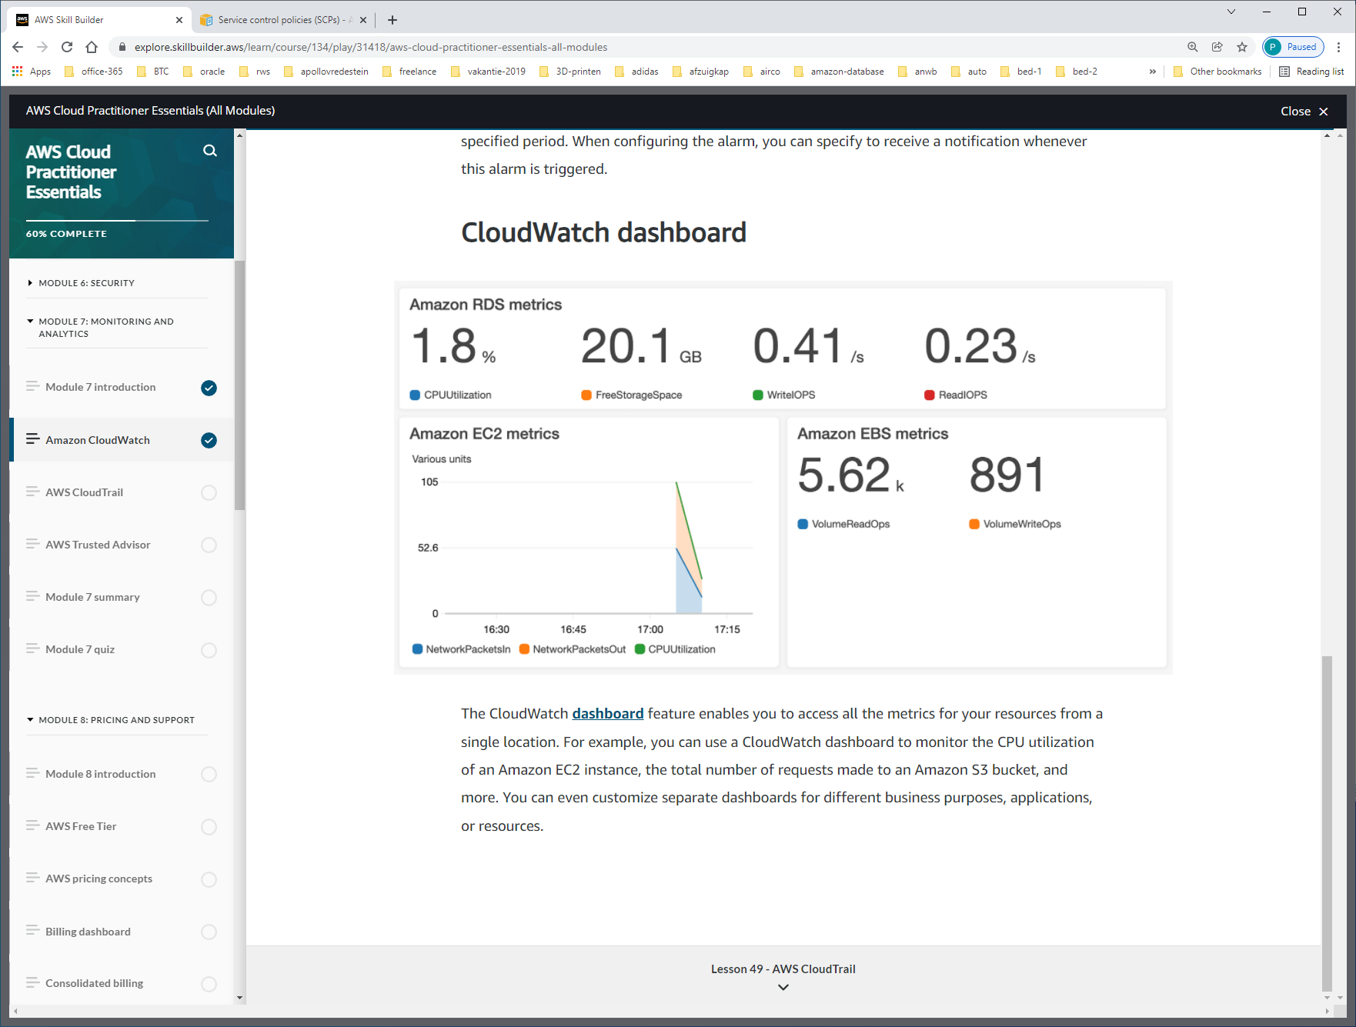

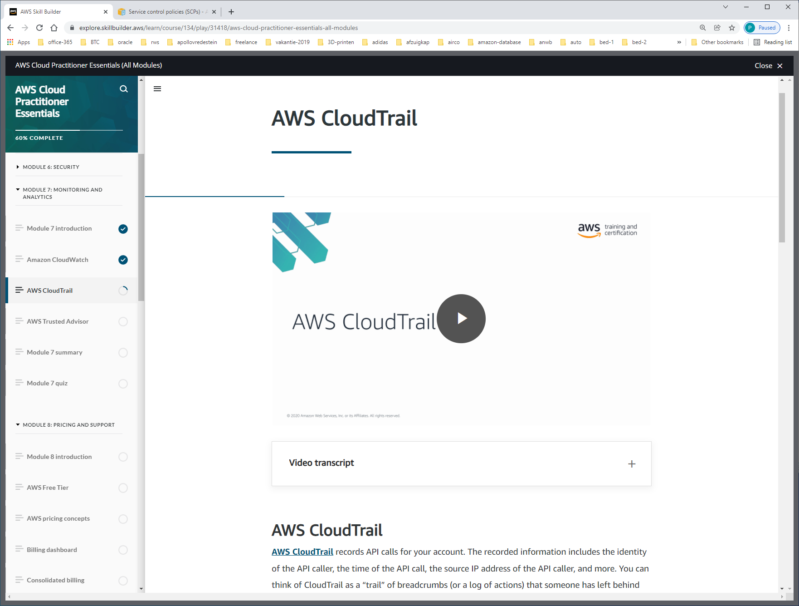

[**AWS CloudTrail**](https://aws.amazon.com/cloudtrail/) records API calls for your account. The recorded information includes the identity of the API caller, the time of the API call, the source IP address of the API caller, and more. You can think of CloudTrail as a “trail” of breadcrumbs (or a log of actions) that someone has left behind them.

CLOUDTRAIL = API-AUDITING-TOOL

Every request is logged in cloudtrail-engine. Result opgeslagen in S3, en met VAULT-LOCK beveiligd.

**CloudTrail Insights**

Within CloudTrail, you can also enable [**CloudTrail Insights**](https://docs.aws.amazon.com/awscloudtrail/latest/userguide/logging-insights-events-with-cloudtrail.html). This optional feature allows CloudTrail to automatically detect unusual API activities in your AWS account.

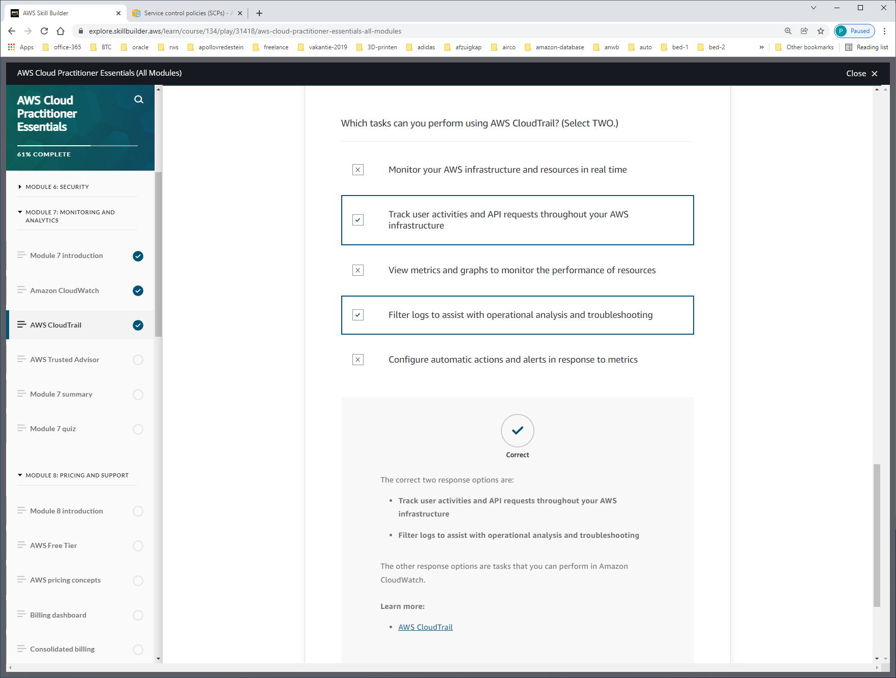

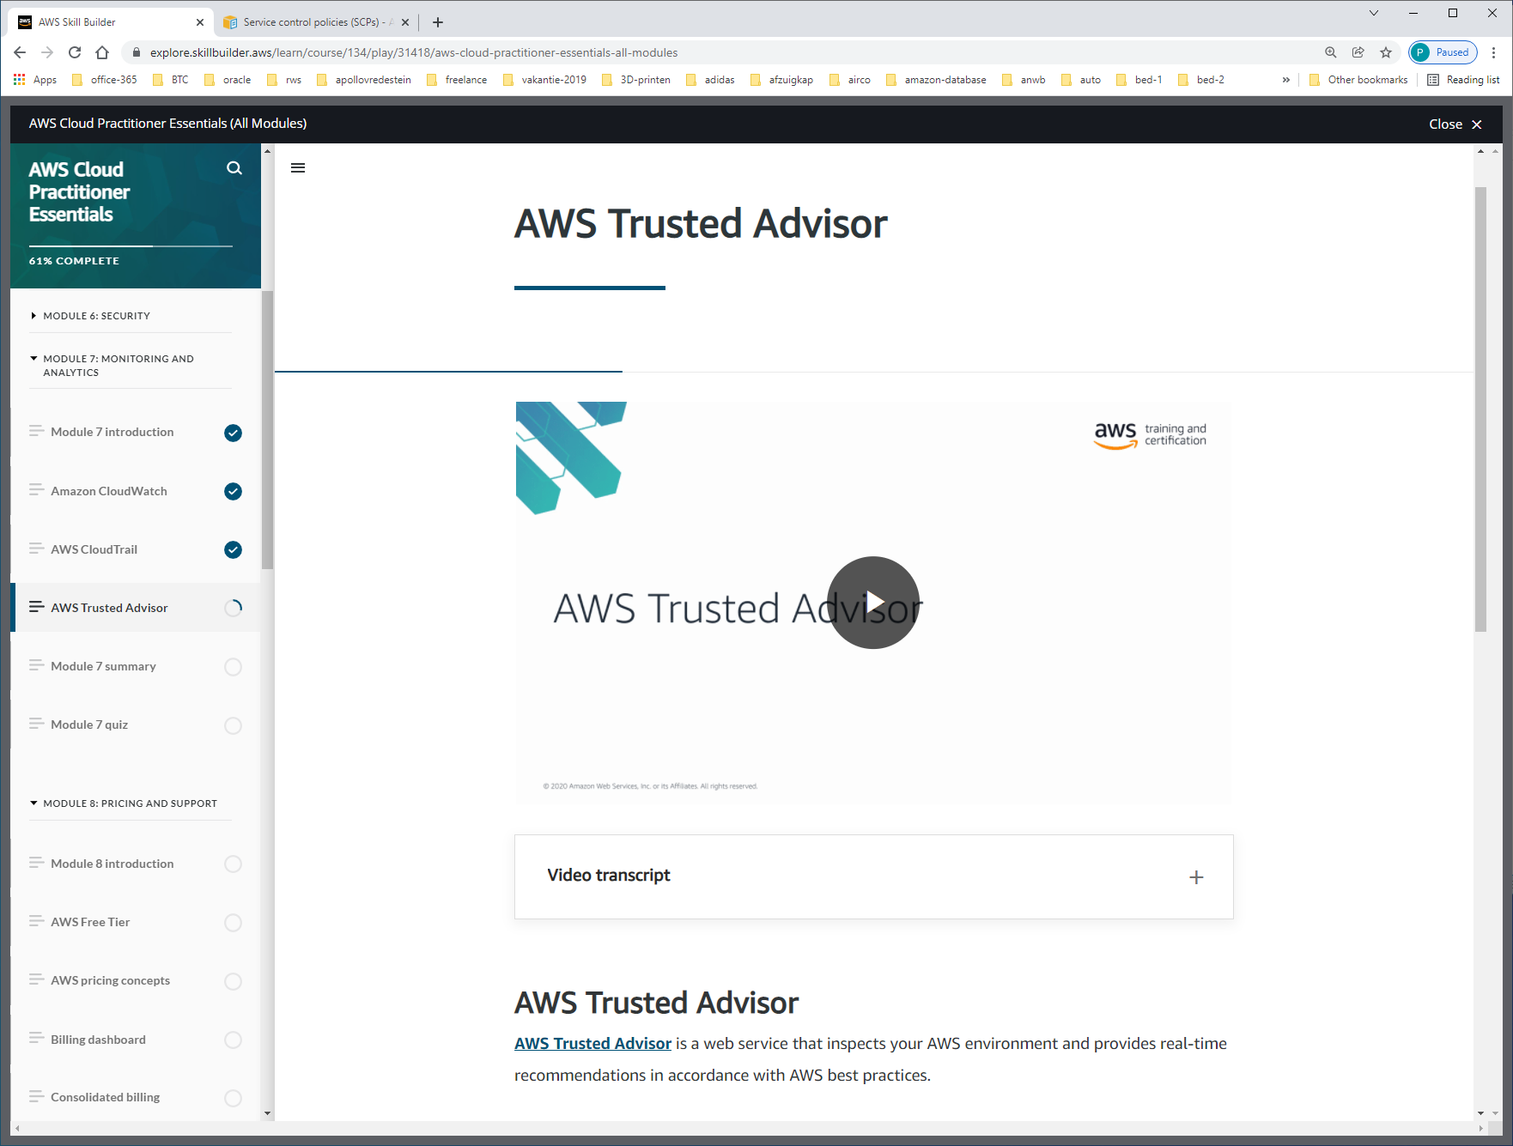

[**AWS Trusted Advisor**](https://aws.amazon.com/premiumsupport/technology/trusted-advisor/) is a web service that inspects your AWS environment and provides real-time recommendations in accordance with AWS best practices.

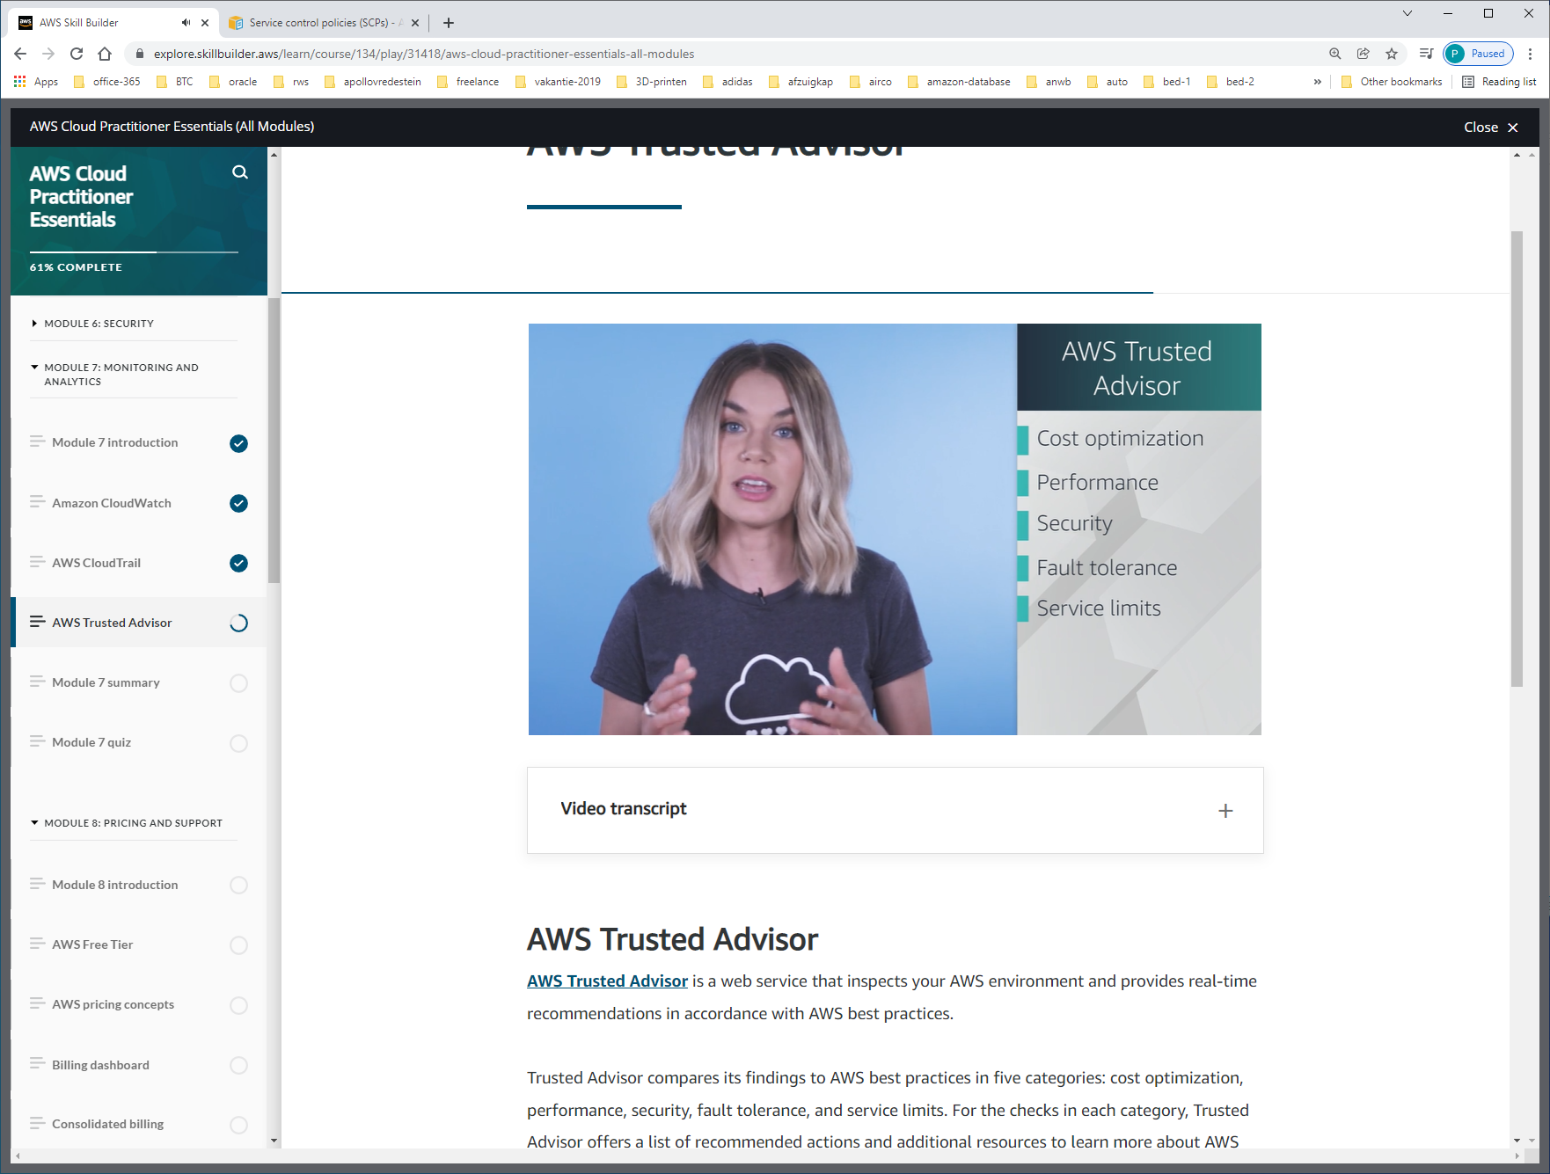

-cost optimization  
-performance  
-security  
-fault-tolerance  
-service-limits

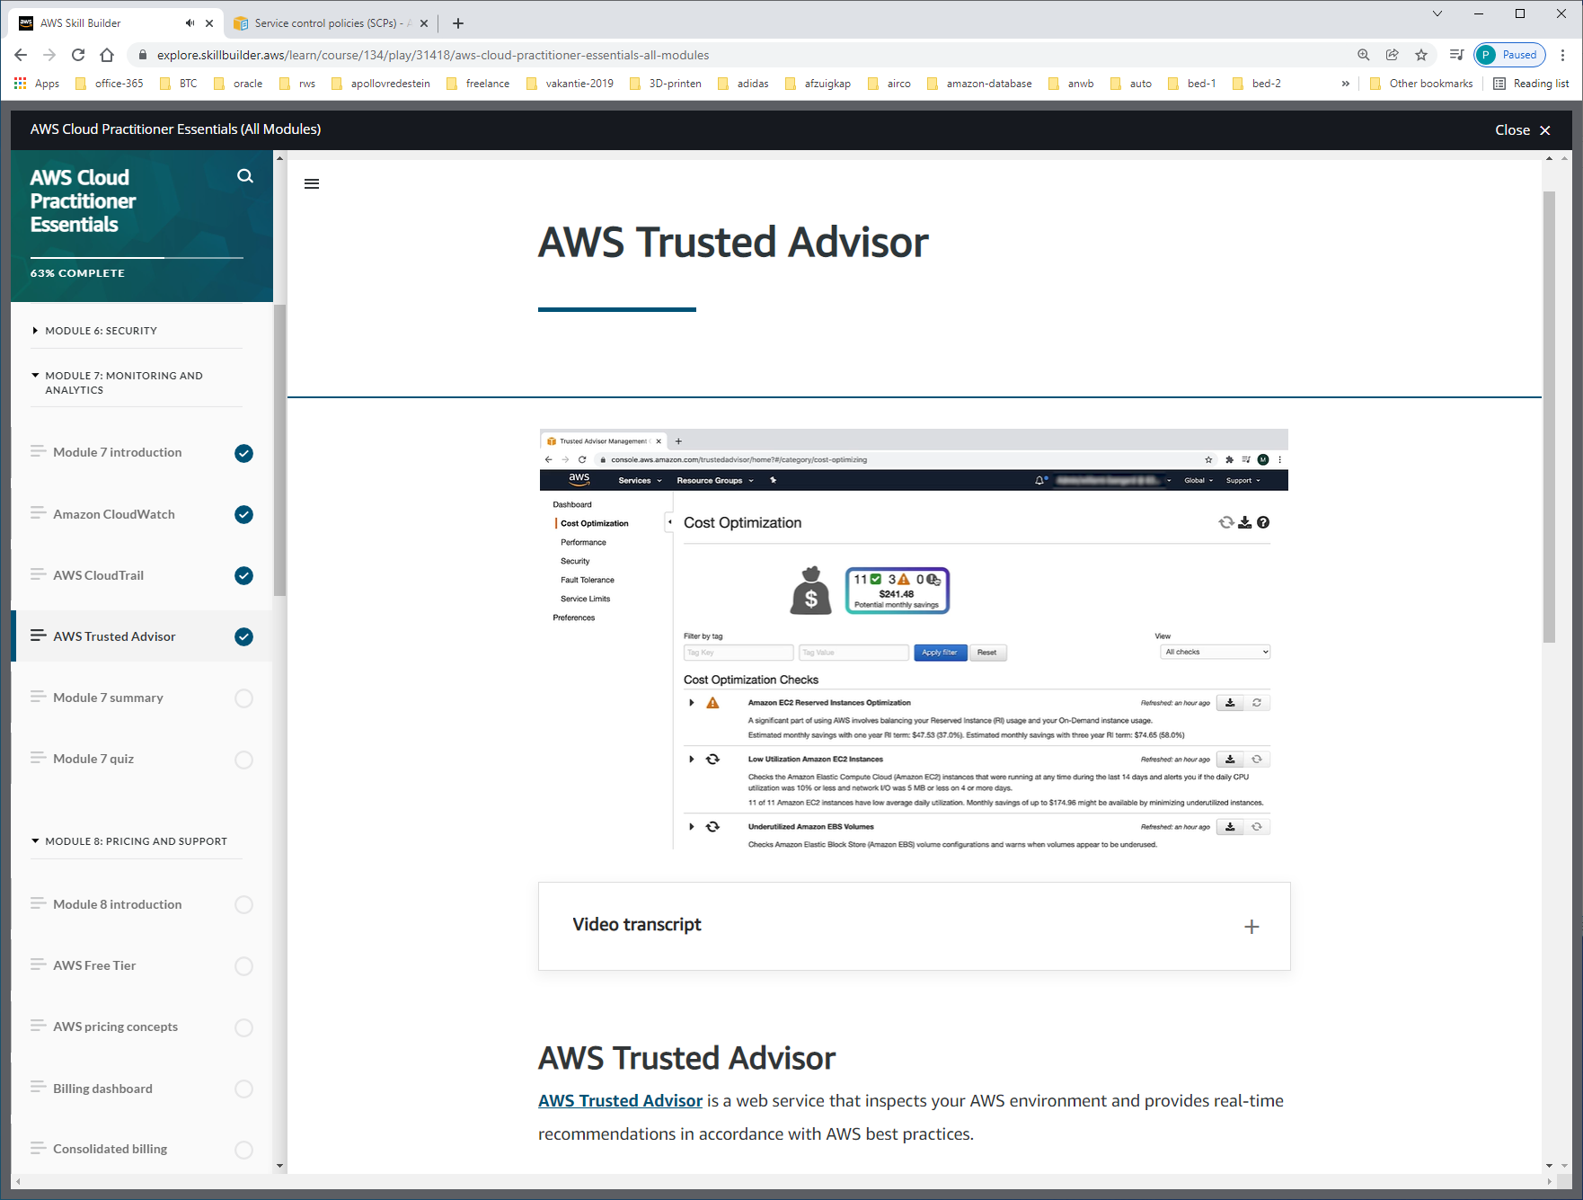

Red=action recommended, orange=investigation recommanded, green=no-problem.

Er staan instances idle. Onderzoeken of deze weg mogen om kosten te besparen.

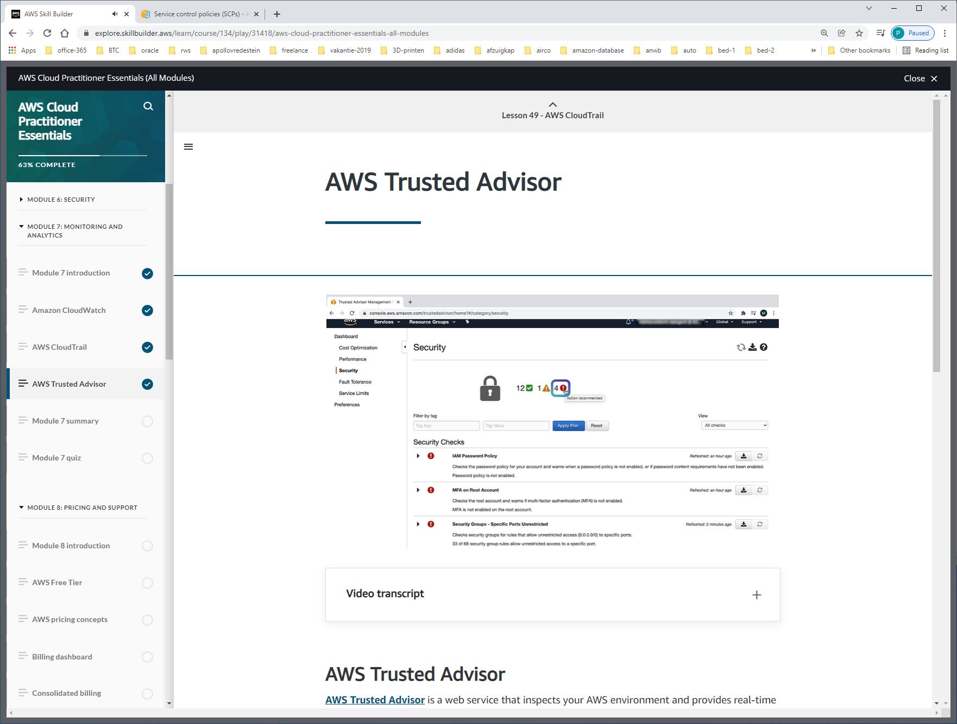

IAM-PASSWORD-POLICY IS WEAK

MFA STAAT NIET AAN VOOR ROOT-USER

SECURITY-GROUPS ALLOWS PUBLIC ACCESS TO EC2-INSTANCES.

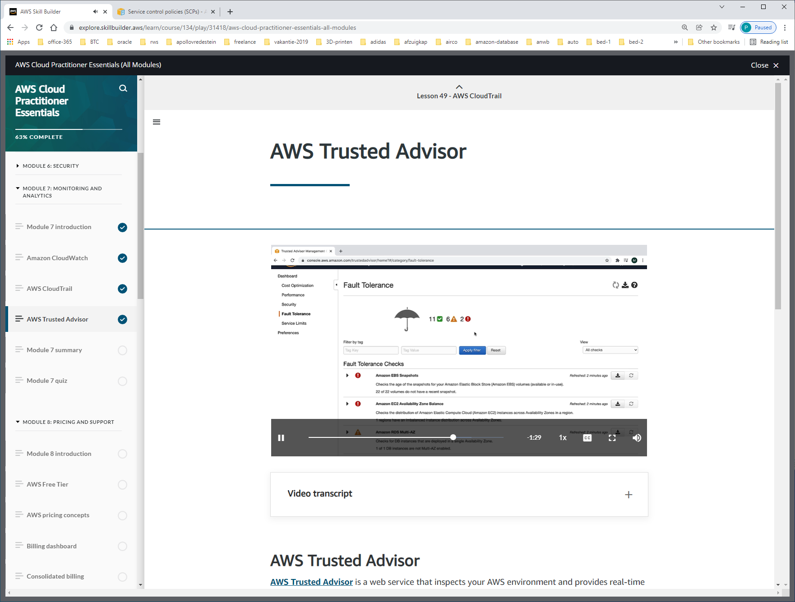

EBS-VOLUMES WITHOUT SNAPSHOTS

EC2 AZ-BALANCE IS AT ACTION-RECOMMENDED-LEVEL. Not properly launched.

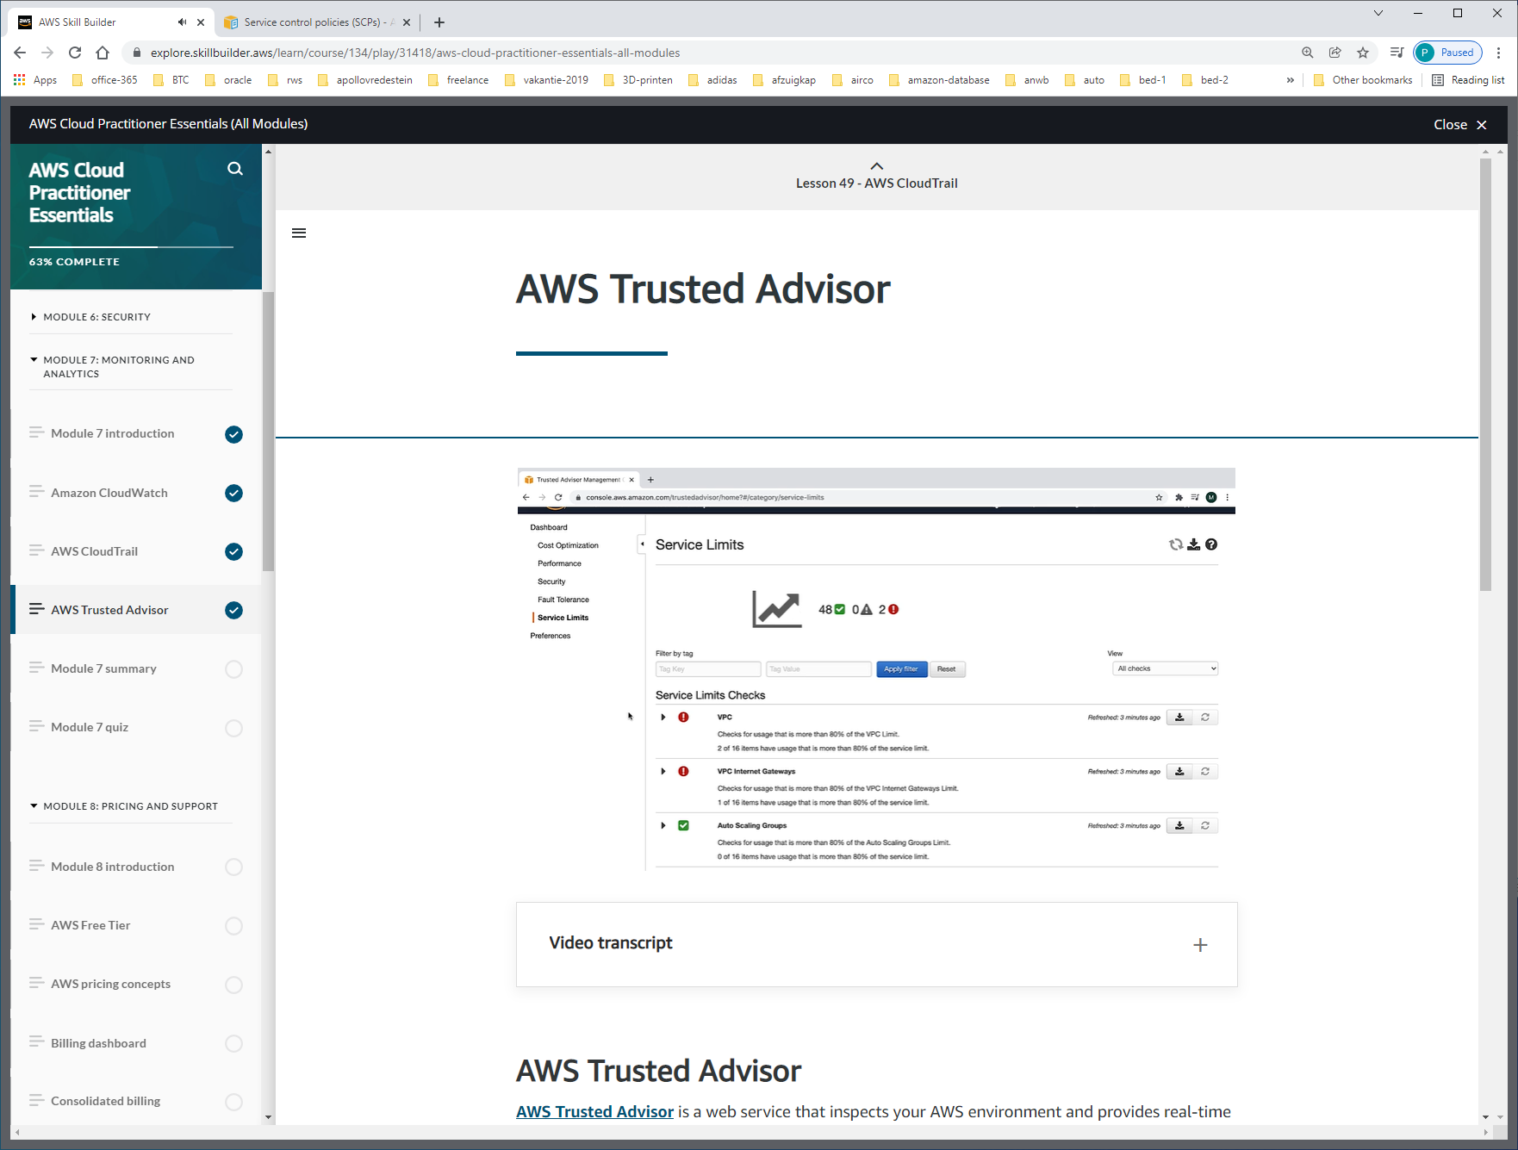

VPC is regional-limit. Mag maar max 5x zijn.

CLOUDWATCH ook RELATIE MET SNS EN EMAIL-NOTIFICATION !!!

